4.4 Real Zeros of Polynomial Functions

Review

Question: How many zeros does each function have?

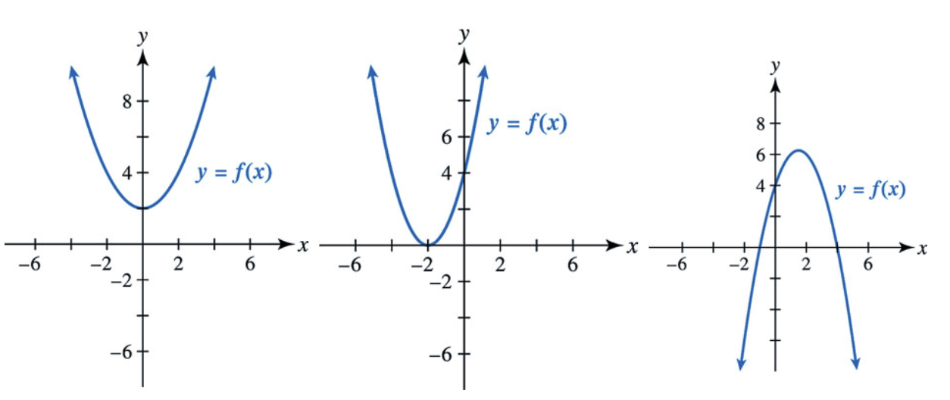
no real zeros 1 real zero at x = -2 2 real zeros at x = -1 and x = 4

Key Idea - A real-zero corresponds to an x-intercept on the function's graph.

Factor Theorem (mathematical statement that can be proven)
A polynomial f(x) has a factor x − k if and only if f(k) = 0.

What does this mean?

f(x) = x² + 5x + 6 = (x+3)(x+2). I know that x = -3 and x = -2 are zeros.
f(-3) = (-3)² + 5(-3) + 6 = 9 - 15 + 6 = 0
f(-2) = (-2)² + 5(-2) + 6 = 4 - 10 + 6 = 0

f(x) has a factor of x + 3, which means that f(-3) = 0. Similarly, f(x) has a factor of (x+2), which means that f(-2) = 0. And vice-versa.

Example
Is x - 2 a factor of $f(x) = 3x^{2}+5x-1$? Why or why not?

If x - 2 is a factor of f(x), then f(2) should equal 0 according to the Factor Theorem. So we need to find what f(2) is.

f(2) = 3(2)² + 5(2) - 1 = 12 + 10 - 1 = 21. No, x-2 is not a factor of f(x), because f(2) is not equal to 0.

Given $f(x) = 4x^{4 }-5x + 7$, is x - 1 a factor of f(x)?
Solution:
k = 1. You need to find the value of f(1).
$f(1) = 4(1)^{4}-5(1) + 7=4-5+7=6$
x - 1 is not a factor of f(x), because f(1) is not equal to 0.

x + 3 is a factor of f(x). Which of the following statements is true?
a) f(3) = 0
b) f(-3) = 0 [CORRECT]
c) f(0) = 3
d) f(0) = -3
Given x + 3, what is k? k = -3

I know that f(5) = 0. Which of the following is a factor of f(x)?
If f(5) = 0, what is k? k = 5, x - 5
a) x
b) x + 5
c) x - 5 [CORRECT]
d) 5 + x

Graphically, this means that x = k is a zero or the x-intercept.

The four statements below are equivalent.
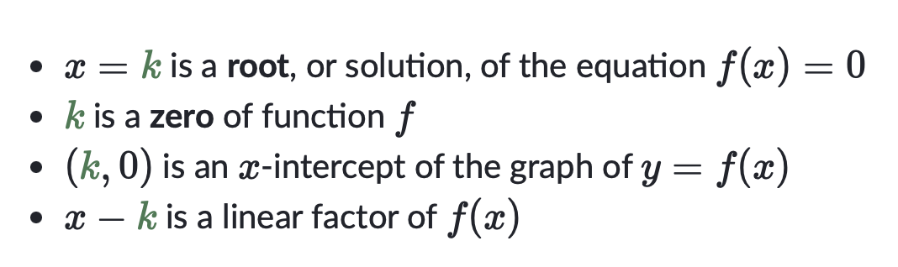
Question: If 3 is a zero of f(x), what other statements can we say about f(x)?
k = 3. This means that x = 3 is a root or solution. 3 is a zero, x-intercept of f. (3, 0) is on the graph of f. x - 3 is a factor of f(x).

x-intercepts, Zeros, and Factors
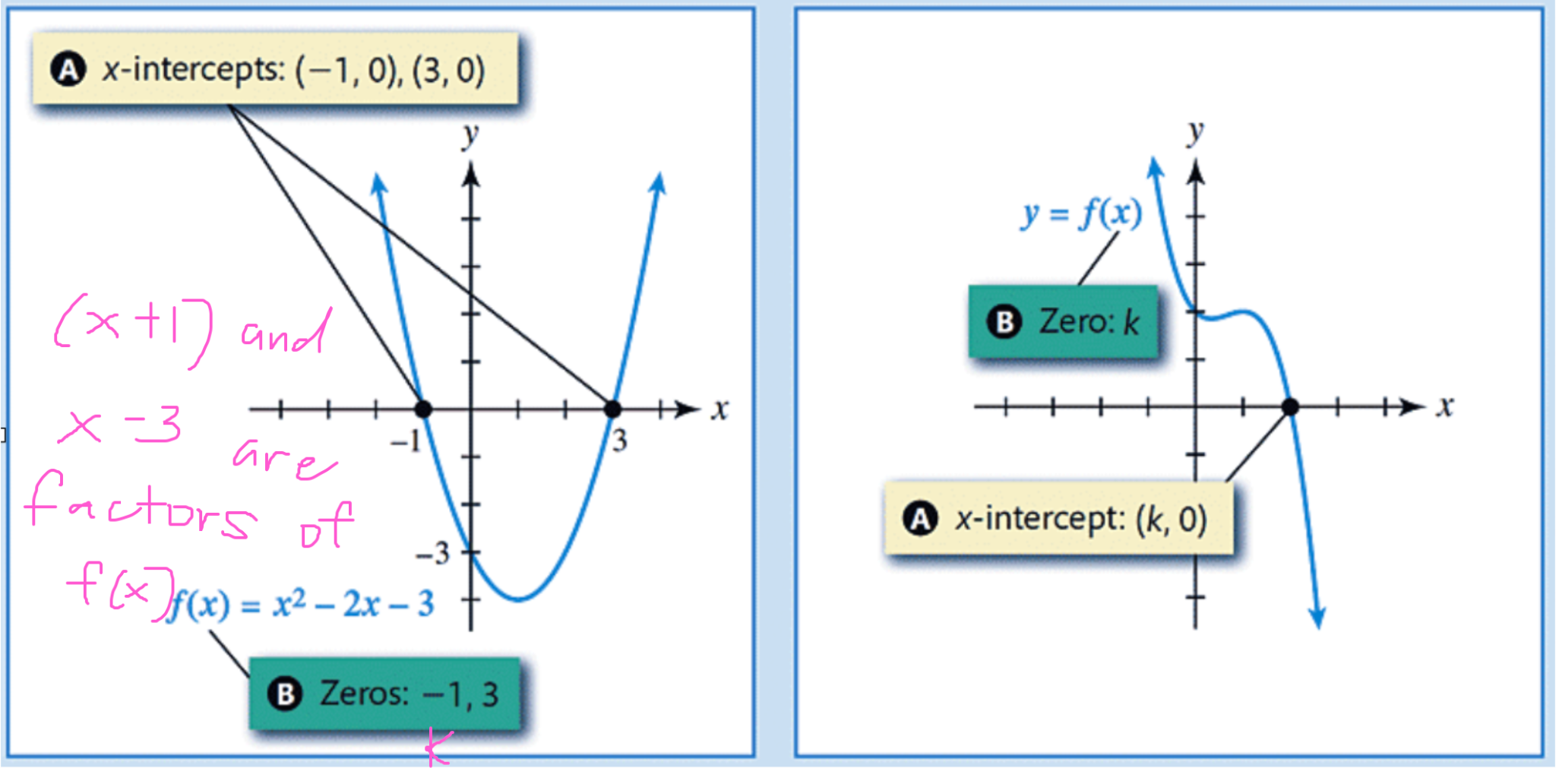

Question: What can we conclude about the factors of each function above?
First image x + 1 and x - 3 are factors of f(x). Second image x - k is a factor of f(x).

Multiplicity
The multiplicity of a zero is the exponent of the corresponding factor.

$f(x) = (x+2)^{1}(x-5)^{3}$

I know that x + 2 is a factor of f(x)
I know that $(x-5)^{3}$ is also a factor of f(x)

I would then say that k=-2 is a zero with multiplicity 1
I would also say that k=5 is a zero with multiplicity 3

$f(x) = (x-1)^{5}(x+1)^{4}$. Find the zeros and their corresponding multiplicities.

zero of 1 with multiplicity is 5; zero of -1 with multiplicity 4
The multiplicity of a zero determines the behavior of the function around its zeros.

If the multiplicity is an odd number (like 1, 3, 5, 7, ...), the graph of the function crosses the x-axis.

If the multiplicity is an even number (like 2, 4, 6, 8, ...), the graph of the function bounces off of the x-axis.

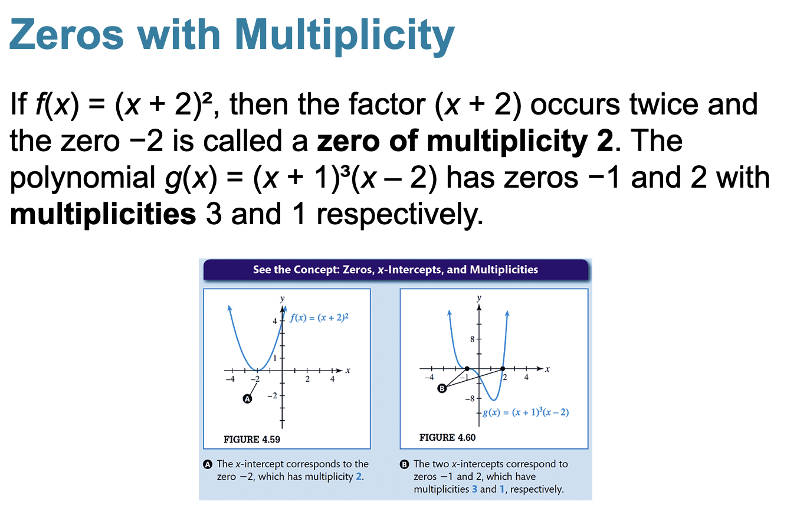

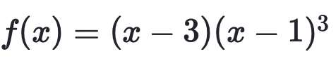
Which zero has a multiplicity of 3?

x-1 is the factor, the zero is 1
the zero k=1 has a multiplicity of 3.

How does the function behave around each zero?
Since 3 is odd, the function crosses the x-axis at x = 1 (1, 0).

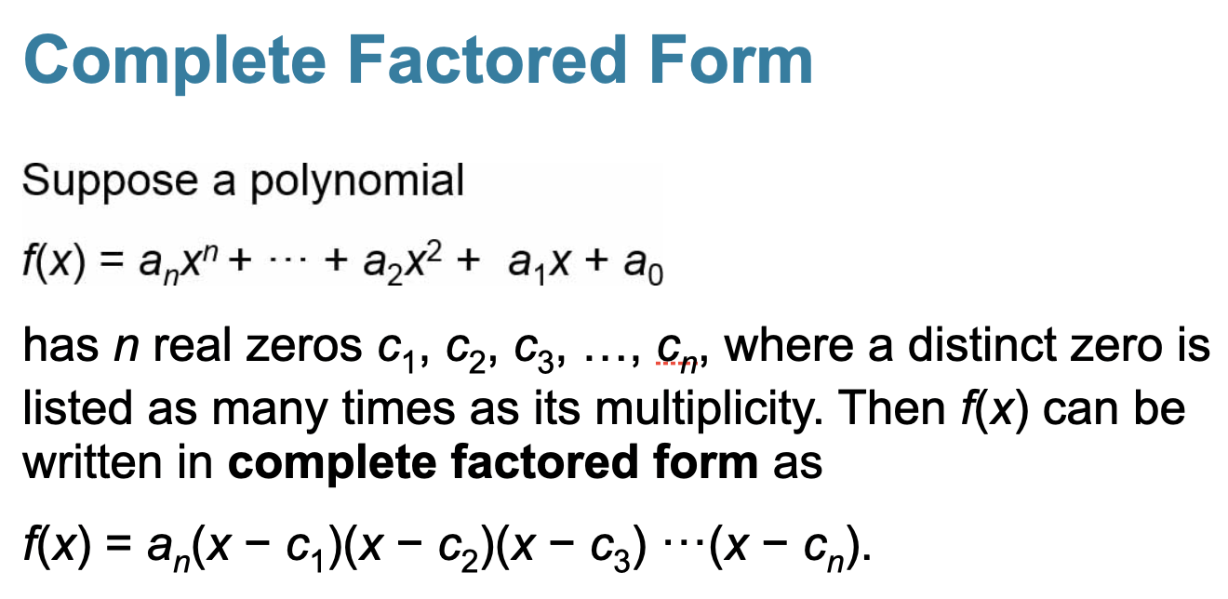

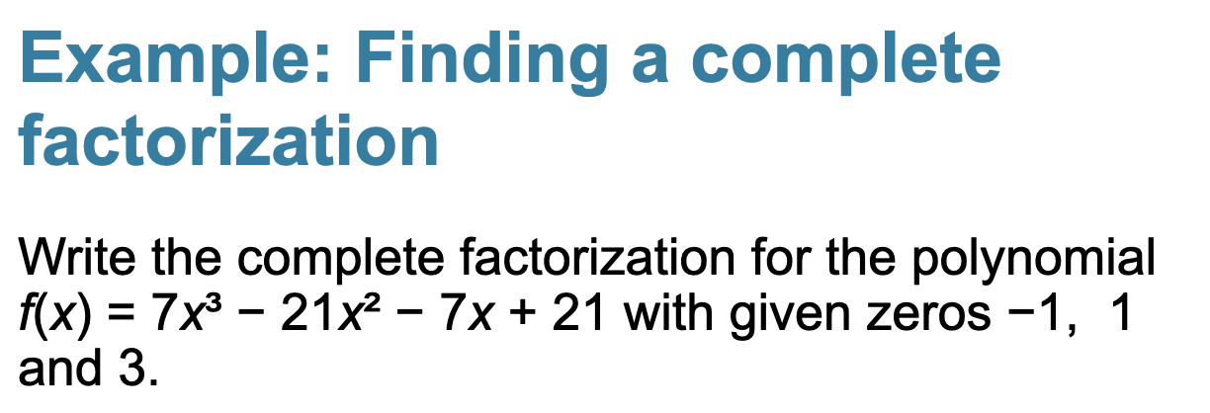

For the zero with k = -1, the corresponding factor is x - (-1) = x + 1
For the zero with k = 1, the corresponding factor is x - 1
For the zero with k = 3, the corresponding factor is x - 3

f(x) = 7(x+1)(x-1)*(x-3)

7 is the leading coefficient.

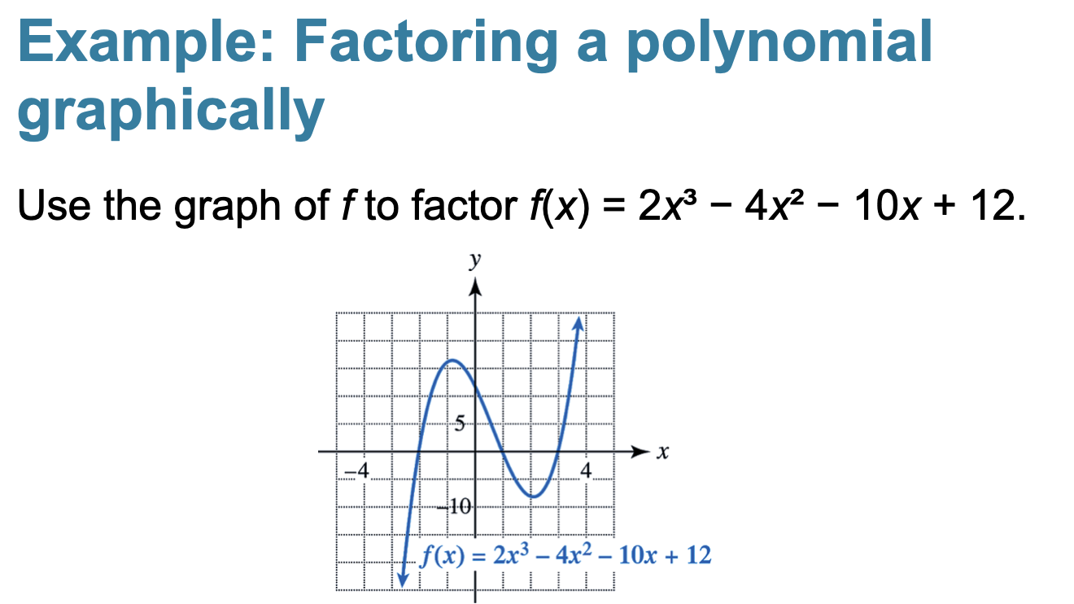

What are the zeros? -2, 1, 3
x+2, x -1, and x-3 are the corresponding factors

f(x) = 2(x+2)(x-1)(x-3)

